PARISH PROFILE 2018

St. John the Evangelist,
Wroxall, Isle of Wight

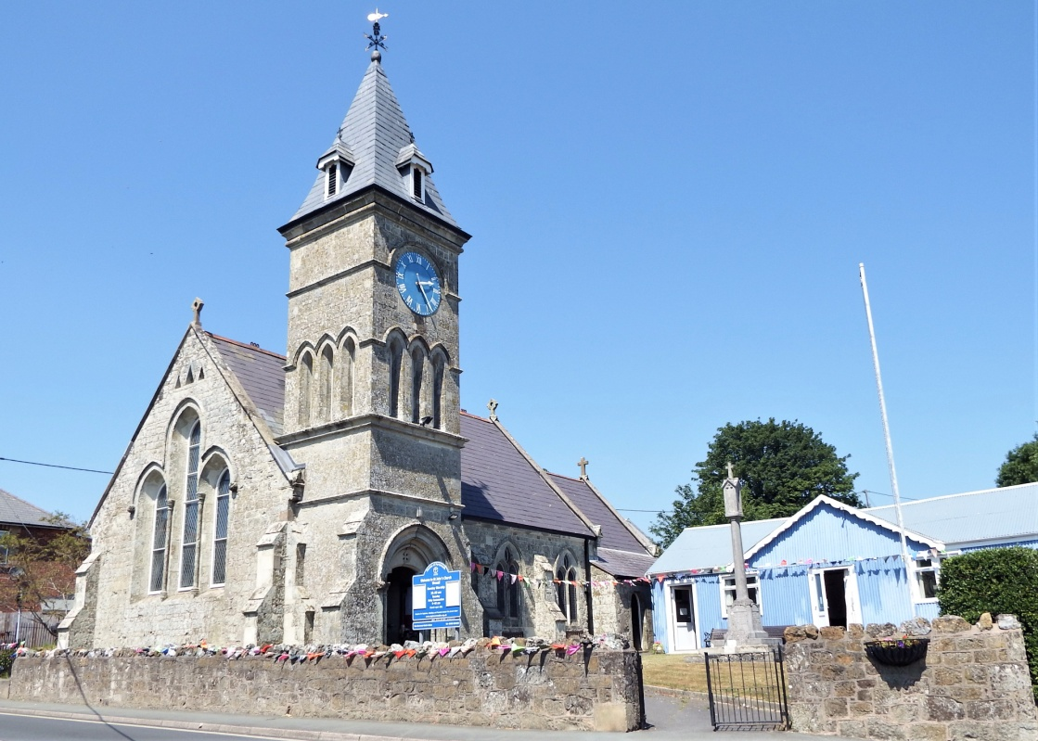

St John the Evangelist, St John’s Road, Wroxall, Ventnor,
Isle of Wight, PO38 3EE
Website: http://www.stjohnswroxalliw.org.uk

Are you a prayerful person with a passion for the Gospel, good liturgy and a real heart for pastoral care?

If so, the Parish of St John’s, Wroxall, Isle of Wight will interest you!

What we are looking for in our new House for Duty Priest:

- Must have a good sense of humour
- Rooted in spiritual values
- Prayerfully led by the Holy Spirit
- Can encourage all gifts of the congregation and to foster them
- Able to continue to develop the close ties with the community and foster their gifts
- Will move the church forward
- A good listener, compassionate and able to relate to a wide range of people
- Open-minded

The Isle of Wight

The island is approximately 24 miles west to east, 12 miles north to south, with a population in the region of 140,000. There are good ferry links to the island from Portsmouth to Fishbourne, near Ryde, Southampton to Cowes, and Lymington to Yarmouth. There is also a Hovercraft service from Southsea to Ryde and a train from Ryde to Shanklin which is fairly close to Wroxall. The County Town is Newport, approximately 8 miles from Wroxall, where St Mary’s Hospital is situated. The Isle of Wight has beautiful scenery and beaches, with no motorways affording a slower pace of life! Further information is available at www.iwight.com

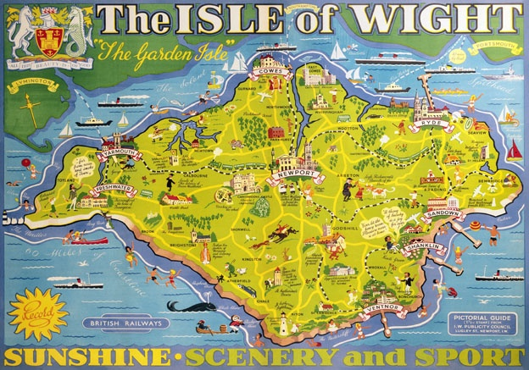

Wroxall
Wroxall

Wroxall is situated on the south side of the island and is a very friendly village, with a good community spirit. It lies in the valley between Stenbury Down and St Martin’s Down, which are designated as areas of outstanding natural beauty. The village is surrounded by open countryside and farmland, therefore many walkers and cyclists visit here. Regular bus services keep Wroxall linked to the rest of the Island and to the ferries. Wroxall is very fortunate to have its own minibus which is used by the young and old of the community, as well as supporting St John’s Church.

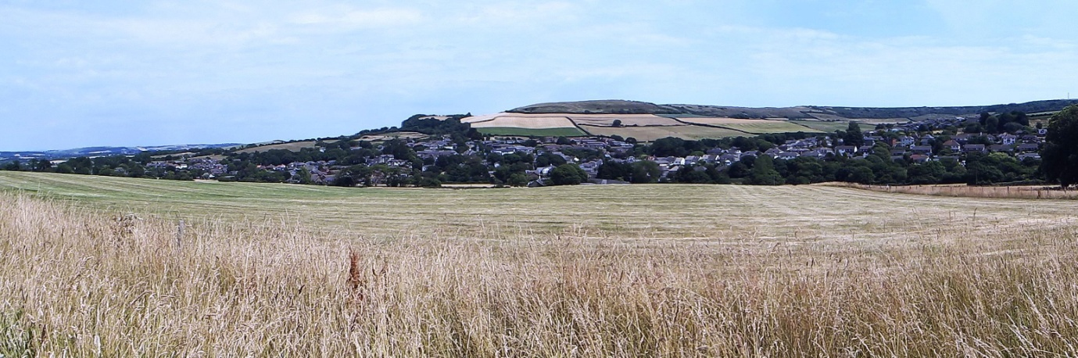

View of Wroxall village

The population estimate for 2016 was 1,715 and, in common with the Island as a whole, there are a high proportion of retired people. Wroxall is 2.5 miles from Shanklin and 2 miles from Ventnor, both of which are on the coast and have lovely beaches. There are numerous shops in these towns and Ventnor is well-known for its microclimate, having a large Botanic Garden with plants from around the world.

There is a balance of private and social housing, Worsley Court which is a housing complex for the elderly, a community primary school, a local shop with integral post office, a community centre, a public house (at the time of writing), a builders merchants and a Methodist Church with which we sustain strong links. There are Cubs, Scouts and Brownies groups in the village and a playing field as well as allotments.

Wroxall is mentioned in the Doomsday Book and Appuldurcombe House has gardens designed by Capability Brown. It was once the home of the Worsley family and is open to the public from April to September. Appuldurcombe Gardens Holiday Park lies within the village, as does the Donkey Sanctuary, with which we also have strong ties. This is situated on the outskirts of the village and services are held here to bless pets and all animals, as well as services at Easter, Harvest Festival and Christmas.

Church History

St John’s was built in 1875 as a Chapel of Ease and consecrated on the 18th December 1877. Originally the church consisted of a chancel, nave, organ chamber, south porch and a small western belfry housing one bell.

The present day church has a tower housing a clock and belfry that contains a carillon of eight bells. These are called “The Silver Jubilee Bells” since the last three bells were added by public subscription as memorial to King George V and Queen Mary’s Silver Jubilee in 1935.

Initially, the interior of the church was very plain but the addition of some oak panelling and stained glass windows in later years has brightened it up. The reredos above the altar is in three panels of dark wood, painted with a scene of calvary and has been recently restored. A triple stained glass window depicting the Ascension surmounts the altar. Five other stained glass windows adorn the church. A baptistry was included at the western end. Behind the lectern is an oil painting of the Virgin and Child given by the children to their church at Christmas 1941.

A hall was built adjacent to the church in 1903 as a venue for church meetings and other community functions. Also standing within the grounds of the church is the village war memorial where we hold our annual village Armistice Day service, which is well attended. At the present time the church building is having on-going repairs.

The Church today

The Parish is part of the Isle of Wight Deanery in the Diocese of Portsmouth. A House for Duty will be provided for our new priest. This is within the village and is a four bedroom house, with kitchen, dining room, sitting room, bathroom, downstairs cloakroom, hall, very large porch and a separate office outside contained within the generous-sized, rear south facing gardens. There is also an outside shed and summer house. The property is in good order with stunning views.

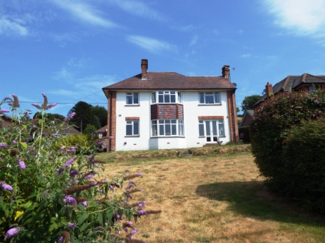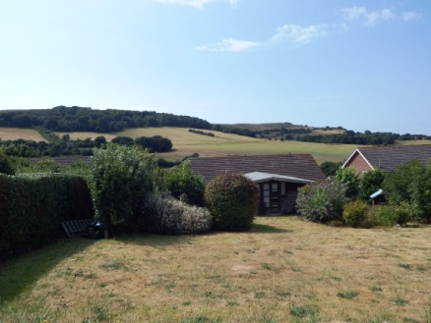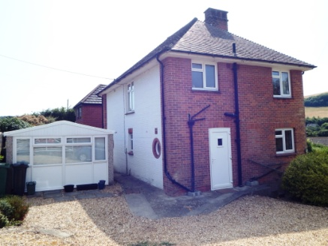

House for duty

St John’s has seating capacity for 120 people. Our Sunday morning service averages 40 people, many more on special occasions. Our fellow Christians at the nearby Methodist Church and other organisations sometimes join us.

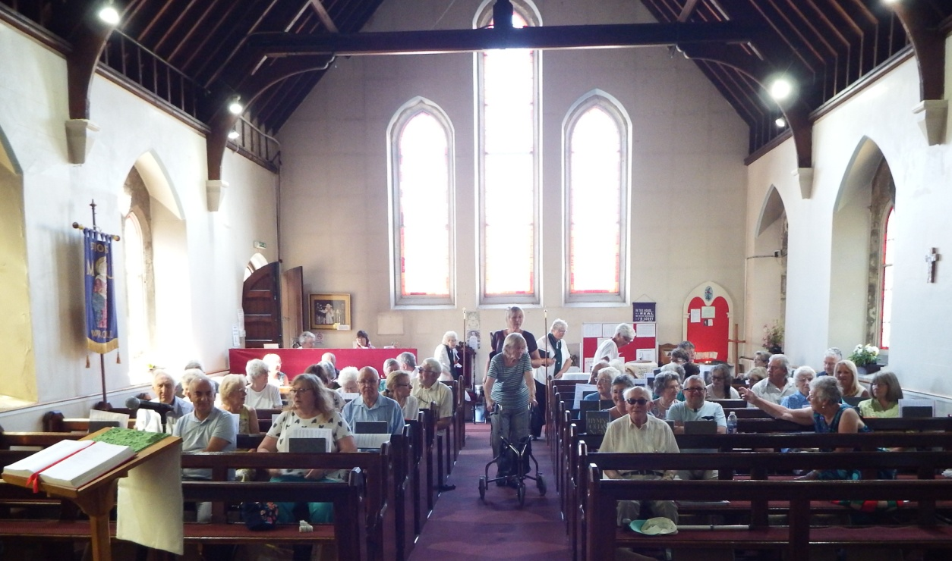

Service
Services at St Johns

Sung Eucharist 10.00 am 2nd, 3rd, 4th and 5th Sundays
All Age Worship 10.00 am 1st Sunday
Holy Communion 11.15 am 1st Sunday
Holy Communion BCP 9.45 am Tuesday

St John’s holds services celebrating the Christian calendar:
Ash Wednesday Eucharist with Ashes
Mothering Sunday
Holy Week services:
Daily Compline, Maundy Thursday Eucharist, Good Friday Children’s Service & Vigil
Easter Eucharist
Ascension Day Eucharist
Harvest Festival
All Souls Service
Remembrance Sunday
Christingle
Midnight Mass
Family Christmas Eucharist
Epiphany Eucharist
Candlemass

St John’s has a variety of annual outreach services:
Pancake Day service
Flower Festival Service of Hymns and Readings
Animal Blessings at the Donkey Sanctuary
Harvest Festival Service of Hymns and Readings
Carols around the Christmas tree
Carol service
Tree and Crib Service
Worship and Liturgy

We have used Common Worship as the basis for our Eucharistic Services since 2000. On Tuesday mornings the Holy Communion Service is from the Book of Common Prayer. The congregation attend the annual Covenant Service at Wroxall Methodist Church, whilst Wroxall Methodists attend the Palm Sunday celebrations and some other services at St John’s during the year.

Ministry Team

This team meets regularly to consider how best to serve our church and village community. The team is made up of the Parish Priest, one churchwarden, one deputy churchwarden and a Health and Safety Manager.

Family Service Planning Team and involvement of children

This team used to meet monthly to plan the All Age Worship Service on the first Sunday of the month. Each month a different theme was planned around a bible reading; hymns and prayers were chosen around this theme.

Music and Choir

We have a small choir of eight or nine, who can raise the roof when required. They always sing on Sunday mornings, choosing hymns using the lectionary to ensure that they fit in with the service. They also sing at special services, weddings, baptisms and funerals without payment as service to the community. We have two organists who alternate to accompany the choir.

Church hall

There is a hall in the grounds of the church that is widely used for our church events. We are a very sociable church family and offer many activities for our community to come along to. We not only see this as a fund-raising opportunity, but very much part of our outreach to our village and beyond. Examples of some of our regular activities are: weekly coffee mornings, monthly scrabble, whist, music and poetry, ‘Lunch Place’, films and quizzes.

At other times of the year we have concerts, cream teas, jumble sales, craft days etc. as fund-raisers. There is an annual Flower Festival, Harvest Supper, Christmas Fair and Carol concerts. We advertise all our events by way of a Notice Board within our grounds and through our Village magazine “The Way” which is funded by Wroxall Parish Council and delivered FREE to homes in the village or available in the local shop.

Wroxall Welfare Group, sewing class, the W.I. and other groups all use the hall regularly and it is often booked for birthday parties and other social events. The hall is managed by two members of the congregation.

The hall is also used by other groups and individuals for hire at a cost of £10 per hour, subject to and within the parameters of the PCC and Health and Safety requirements. The hall has a well equipped kitchen, access for disabled persons and a toilet with disabled and baby changing facilities. There are many tables and chairs, play mats, music centre and an electronic screen used for film nights. It benefits from electric heating and is in good repair, having been recently redecorated internally by volunteers through an Island scheme.

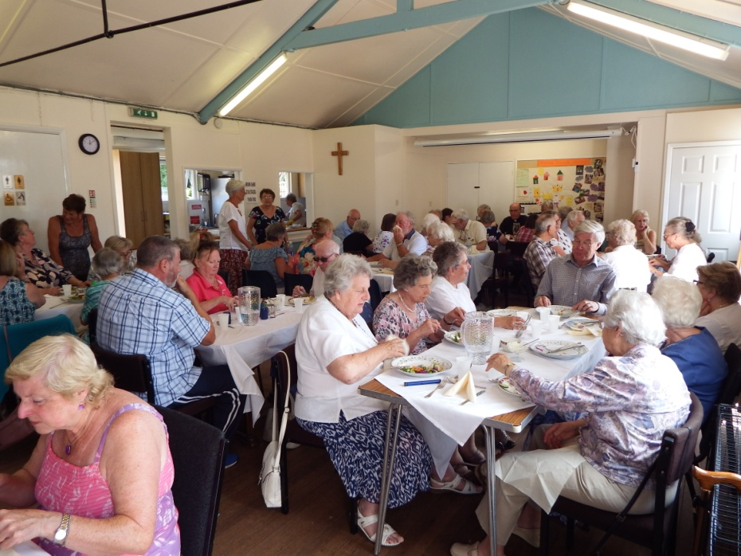

Church hall interior

Wroxall School

There is one school in the village, Wroxall Primary. The school has approximately 180 pupils and has been increasing in number due to reorganisation of the schools on the Island. Pupils who attend come from the village as well as surrounding towns and villages. The school is federated with two other village primary schools, Godshill and Rookley/Chillerton Primaries. All three schools come under one governing body.

The school caters for children from the age of four to eleven. There is an independent pre-school on site, which takes children from the age of two until school age. Teenagers in the area travel to Newport, Sandown and Ryde for senior schools. There is also a combined Church of England and Roman Catholic Senior School in Newport, which takes children of all ages.

We have previously had strong links with Wroxall School and we would hope that the new priest will be able to expand on these.

The following policies have been adopted by the PCC:
- Baptism
- Communion before confirmation
- Marriages
- Re-marriage of divorcees
- Child protection
- Safeguarding of vulnerable adults
Vision, hope and prayer for the future:

St John’s church was built to serve the needs of the community in the 19th century. Our vision, hope and prayer are that it will continue to do so in the 21st century and beyond. As a church we very much believe in prayer to develop our own spirituality, studying the Bible and being actively involved in prayer for our community, for our church and for each other.

We have a Prayer Chain to offer emergency prayer for people, countrywide sometimes. All are treated with the utmost confidence. We consider prayer to be the engine room of the church.

We are a church ever-ready to move on and go deeper into our relationships, firstly with God, then with each other. Many are open to new ways of worship.

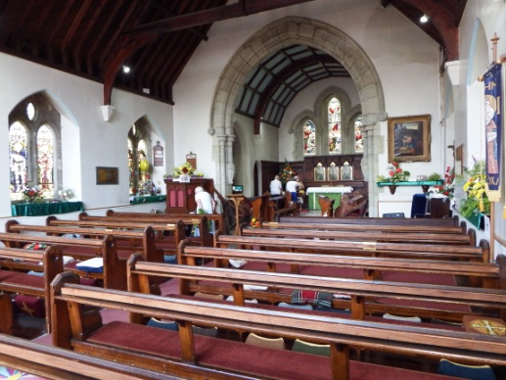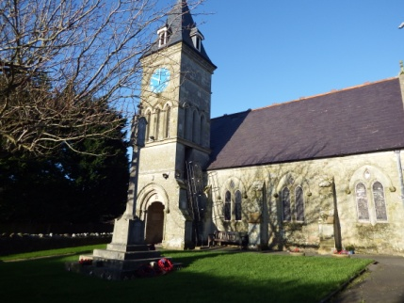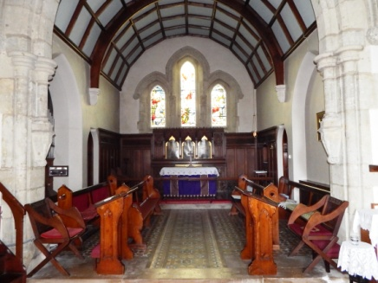
Views of St John’s

Financial Statement of the Parochial Church Council
For the Year Ended 31st December 2017
Independent Examiner's Report

To the PCC of St John the Evangelist, Wroxall

This report on the financial statements of the PCC for the year ended 31December 2017, which are set out on pages 1 and 2, is in respect of an examination carried out in accordance with the Church Accounting Regulations 2006 ("the Regulations") and s.43 of the Charities Act 1993 ("the Act").

Respective responsibilities of the PCC and the Examiner

As members of the PCC you are responsible for the preparation of the financial statements; you consider that the audit requirement of the Regulations and section 43(2) of the Act do not apply. lt is my responsibility to issue this report on those financial statements in accordance with the terms of the Regulations.

Basis of this report

My examination was carried out in accordance with the General Directions given by the Charity Commission under section 43(7)(b) of the Act and to be found in the Church Guidance, 2006 edition. That examination includes a review of the accounting records kept by the PCC and a comparison of the accounts with those records. lt also includes considering any unusual items or disclosures in the financial statements and seeking explanations from you as trustees concerning any such matters. The procedures undertaken do not provide all the evidence that would be required in an audit, and consequently I do not express an audit opinion on the view given by the accounts.

Independent Examiner's statement

ln connection with my examination, no matter has come to my attention:

- which gives me reasonable cause to believe that in any material respect the requirements:

1. to keep accounting records in accordance with section 41 of the Act; and

2. to prepare financial statements, which accord with the accounting records and comply with the requirements of the Act and the Regulations have not been met; or

(2) to which, in my opinion, attention should be drawn in order to enable a proper understanding of the accounts to be reached.

Signed: M Cooper 6th February 2018
Michael Cooper, 3 Priory Walk, Niton, Ventnor, PO38 2DS
St John the Evangelist Wroxall - Balance Sheet 2017
Statement of Assets For the Year Ended 31st December 2017
 |  | Unrestricted funds | Restricted funds | Total 2017 |  | Total 2016
Cash Funds
Bank Account Current |  | £ 7,377.18 |  | £ 7,377.18 |  | £ 5,314.66
Bank Account Building Fund |  |  | £ 10,017.61 | £ 10,017.61 |  | £ 5,251.12
Bank Account Flower fund |  | £ 258.25 |  | £ 258.25 |  | £ 161.95
Cash in Hand |  | £ - | £ - | £ - |  | £ -
 |  | £ 7,635.43 | £ 10,017.61 | £ 17,653.04 |  | £ 10,727.73
Notes:
1 The building fund has been used to pay for essential repairs to the church walls and the balance is now £723
2 The balances for 2017 take into account all transactions relevant for 2016 but were debited or deposited from the bank accounts in 2018

St John the Evangelist Wroxall - Income & Expenditure 2017
Income & Expenditure as at |  | 31st December 2017
 |  |  | 2017 |  |  | 2016
Income Unrestricted
 | Church | Parish Giving scheme | £ 6,618.27 |  |  | £ 5,478.19
 |  | Planned Giving | £ 6,839.70 |  |  | £ 6,548.18
 |  | Collections - Sunday | £ 2,408.04 |  |  | £ 2,219.55
 |  | Collections - Gift aid | £ 5,616.70 |  |  | £ 339.00
 |  | Fetes, Bazaars | £ 3,962.16 |  |  | £ 2,122.77
 |  | Sundry Donations and Charities | £ 1,654.36 |  |  | £ 2,975.49
 |  | Fees Paid to the PCC Marriages | £ 1,011.00 |  |  | £ 461.00
 |  | Fees Paid to the PCC Funerals | £ 2,367.00 |  |  | £ 3,801.00
 |  | Legacy | £ 4,500.00 |  |  | £ -
 |  | Friends of St John's | £ 96.00 |  |  | £ 122.00
 |  | Gift aid refunds | £ 4,140.95 |  |  | £ 2,941.92
 |  | Miscellaneous income | £ 30.00 |  |  | £ 26.00
 |  | Bishop's Appeal | £ - |  |  | £ 16.00
 |  | Queens Birthday events | £ - |  |  | £ 651.11
 |  |  | £ 39,244.18 |  |  | £ 27,702.21
 | Flower Fund |  | £ 273.80 |  |  | £ 327.95
 | Hall | Hire of Hall | £ 2,276.00 |  |  | £ 1,567.00
 |  | Tuesday coffee morning | £ 1,307.70 |  |  | £ 1,299.60
 |  | Film/music nights | £ 529.00 |  |  | £ 631.70
 |  | Quiz, Whist & Scrabble | £ 1,448.00 |  |  | £ 1,377.00
 |  |  | £ 5,560.70 |  |  | £ 4,875.30
Income Restricted
 | Building fund | Vat refund |  |  |  | £ -
 |  | Bank interest | £ 6.62 |  |  | £ 15.40
 |  | Donations | £ 2,806.49 |  |  | £ 704.05
 |  | Smarties | £ 193.50 |  |  | £ 452.99
 |  | Wall safe | £ 659.76 |  |  | £ 509.65
 |  | Lunch place | £ 1,391.52 |  |  | £ 1,339.90
 |  |  | £ 5,057.89 |  |  | £ 3,021.99
 |  | TOTAL INCOME | £ 50,136.57 |  |  | £ 35,927.45
Expenditure
Unrestricted | Church | Insurance | £ 1,257.00 |  |  | £ 1,320.14
 |  | Utilities | £ 1,470.08 |  |  | £ 1,365.10
 |  | Repairs & Maintenance | £ 3,643.50 |  |  | £ 478.33
 |  | Cost of Church Services | £ 938.68 |  |  | £ 585.03
 |  | Salaries, Wages Honoraria | £ 1,914.40 |  |  | £ 1,433.00
 |  | Postage &Stationery | £ 342.34 |  |  | £ 273.92
 |  | Printing | £ 623.63 |  |  | £ 398.26
 |  | Telephone | £ 366.62 |  |  | £ 346.70
 |  | Travel | £ 327.95 |  |  | £ 292.75
 |  | Other Parish Expenditure | £ 1,741.42 |  |  | £ 1,791.72
 |  | Fees to the Diocese | £ 1,702.00 |  |  | £ 2,335.00
 |  | Payments to The Diocese | £ 27,000.00 |  |  | £ 17,750.00
 |  | 5 year survey |  |  |  | £ 660.00
 |  | Payments to Charities | £ 400.00 |  |  | £ 1,244.50
 |  |  | £ 41,727.62 |  |  | £ 30,274.45
 | Flowers |  | £ 177.50 |  |  | £ 166.00
 | Hall | Hall repairs & Maintenance | £ 162.13 |  |  | £ 228.22
 |  | Hall equipment | £ 9.95 |  |  | £ 289.98
 |  | Insurance | £ 134.17 |  |  | £ 910.25
 |  | Catering | £ 118.55 |  |  | £ 291.76
 |  | Utilities | £ 589.94 |  |  | £ 805.85
 |  |  | £ 1,014.74 |  |  | £ 2,526.06
Expenditure
Restricted |  | Building repairs | £ 291.40 |  |  | £ 2,403.91
 |  | TOTAL EXPENDITURE | £ 43,211.26 |  |  | £ 35,370.42
 |  | net surplus/deficit | £ 6,925.31 |  |  | £ 557.03

Adjusted balance as at 31 Dec 2017 |  |  |  |  |  | £ 7,377.18 | £ 258.25 | £10,017.61 | £ 17,653.04
Income & Expenditure as at |  |  |  |  |  | 31-Dec-17
 | Current as at |  |  | 01-Jan-17 |  | £ 5,314.66 |  | 31-Dec-17 | £ 7,377.18
 | Building a/c as at |  |  | 01-Jan-17 |  | £ 5,251.12 |  | 31-Dec-17 | £ 10,017.61
 | Flower a/c as at |  |  | 01-Jan-17 |  | £ 161.95 |  | 31-Dec-17 | £ 258.25
 | cash in hand |  |  |  |  | £ -
 |  |  |  | Total |  | £ 10,727.73 |  |  | £ 17,653.04
 | Receipts as at |  |  | 31-Dec-16 |  | £ 50,136.57
 | Payments as at |  |  | 31-Dec-16 |  | -£ 43,211.26
 | surplus/deficit |  |  |  |  | £ 6,925.31
 |  |  |  |  |  | £ 17,653.04 |  |  | £ 17,653.04
 | Unrestricted |  |  |  |  | Restricted
 | Current account |  |  |  |  | Building account |  | Flower fund
As at 1 Jan 2017 | £ 5,314.66 |  |  | As at 1 Jan 2017 |  | £ 5,251.12 | As at 1 Jan 2017 | £161.95 | £ 10,727.73
Church income | £ 39,244.18 |  |  | Building income |  | £ 5,057.89 | flower income | £ 273.80 | £ 44,575.87
Hall income | £ 5,560.70 |  |  |  |  |  |  |  | £ 5,560.70
Church expenditure | -£ 41,727.62 |  |  | Building expenditure |  | -£ 291.40 | flower expenditure | -£ 177.50 | -£ 42,196.52
Hall expenditure | -£ 1,014.74 |  |  |  |  |  |  |  | -£ 1,014.74
As at 31 Dec 2017 | £ 7,377.18 |  |  |  |  | £ 10,017.61 |  | £ 258.25 | £ 17,653.04

